Assignment 1:

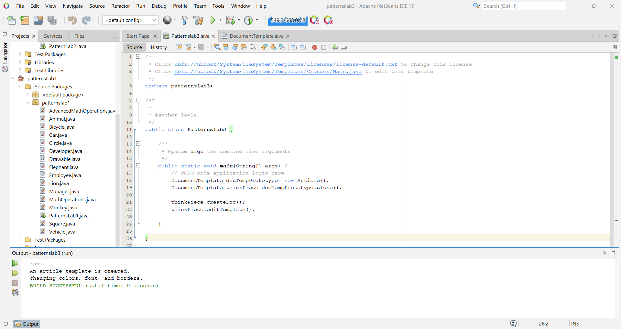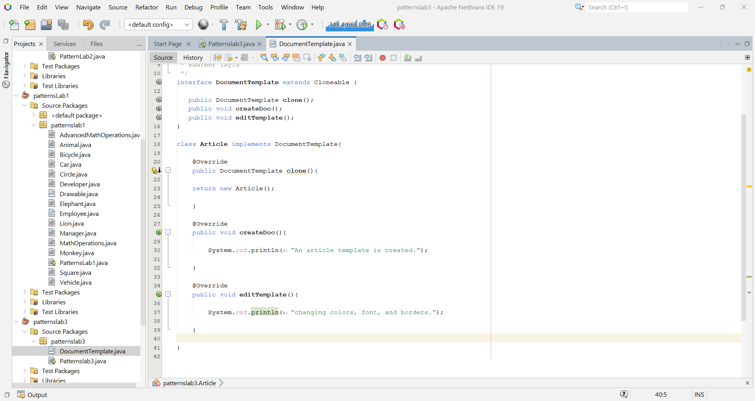

Assignment 2:

